TASK 1
#include <iostream>
#include <ctime>
using namespace std;

void playGame(int secretNumber, int player) {
int guess;
cout << "Player " << player << ", enter your guess (1-100): ";
cin >> guess;

if (guess == secretNumber) {
cout << "Congratulations! Player " << player << " wins!" << endl;
return;
} else if (guess < secretNumber) {
cout << "Too low!" << endl;
} else {
cout << "Too high!" << endl;
}
playGame(secretNumber, player == 1 ? 2 : 1);
}

int main() {
srand(time(0));
int secretNumber = rand() % 100 + 1;
cout << "Welcome to the Number Guessing Game!" << endl;
playGame(secretNumber, 1);
return 0;
}

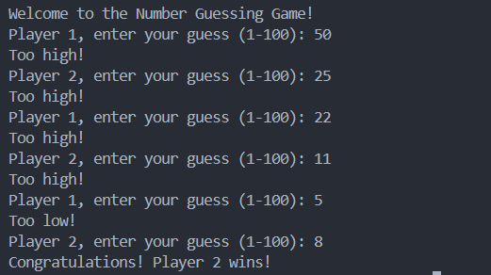
TASK 2
#include <iostream>
using namespace std;

#define N 5

bool isSafe(int maze[N][N], int x, int y) {
return (x >= 0 && x < N && y >= 0 && y < N && maze[x][y] == 1);
}

bool solveMaze(int maze[N][N], int solution[N][N], int x, int y) {
if (x == N - 1 && y == N - 1 && maze[x][y] == 1) {
solution[x][y] = 1;
return true;
}
if (isSafe(maze, x, y)) {
solution[x][y] = 1;
// Move right
if (solveMaze(maze, solution, x, y + 1))
return true;
// Move down
if (solveMaze(maze, solution, x + 1, y))
return true;
// Move left
if (solveMaze(maze, solution, x, y - 1))
return true;
// Move up
if (solveMaze(maze, solution, x - 1, y))
return true;
// Backtrack
solution[x][y] = 0;
}
return false;
}

int main(){
int maze[N][N] = {
{1,0,1,0,1},
{1,1,1,1,1},
{0,1,0,1,1},
{1,0,0,1,1},
{1,1,1,0,1}
};

int solution[N][N] = {0} ;

if(solveMaze(maze, solution, 0,0)){
for (int i = 0; i < N; i++)
{
for (int j = 0; j < N; j++)
{
cout << solution[i][j] << " ";
}
cout << endl;
}
}

return 0;
}

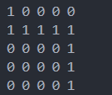

TASK 5
#include <iostream>
using namespace std;

int sumOfDigits(int n) {
if (n < 10) {
return (n % 10 == 0) ? 0 : n;
}
int sum = 0;
while (n > 0) {
sum += n % 10;
n /= 10;
}
return sumOfDigits(sum);
}

int main() {
int number;
cout << "Enter a number: ";
cin >> number;
cout << "Sum of digits: " << sumOfDigits(number) << endl;
return 0;
}

